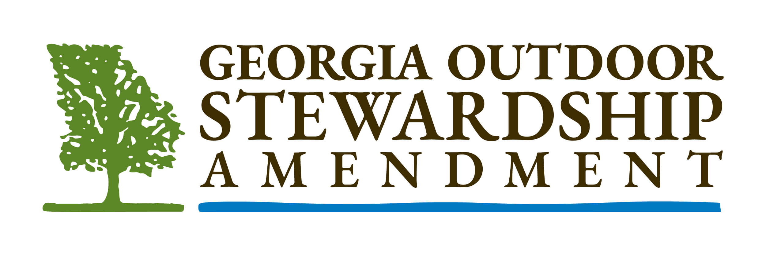

A Historic Opportunity to
Protect our Waters and Lands

Georgia’s economy and quality of life are directly tied to both the water quality of our rivers, lakes and streams and the availability and beauty of our outdoor spaces, wildlife habitats and parks.

This fall, we have a historic opportunity to pass the Georgia Outdoor Stewardship Amendment and protect our waters and lands by constitutionally dedicating a portion of the existing sales tax on outdoor sporting goods without raising any taxes or creating new fees.

If passed, this funding would:

- Protect lands critical to clean drinking water and the quality of Georgia’s lakes, rivers and streams

- Acquire and improve parks and trails for children, families and outdoor enthusiasts to enjoy in communities throughout the state

- Maintain and improve access to wildlife management areas and create new opportunities for hunting and fishing

- Support Georgia’s $27 billion outdoor recreation industry and the jobs it and the other economic sectors that rely upon access to land and water create

If passed, the Georgia Outdoor Stewardship Amendment would dedicate up to 80% of the existing sales and use tax on outdoor sporting goods to the protection of the state’s lands, water, and wildlife without raising or creating any new taxes or fees.

Over $20 million would be dedicated every year for the next ten years. This funding could not be used for any other purpose and would be subject to strict accountability provisions and public disclosure. Only projects consistent with the state’s established goals for conservation would be approved.

The Georgia Outdoor Stewardship Amendment is supported by a coalition of leading conservation organizations including The Conservation Fund, Georgia Conservancy, Georgia Wildlife Federation, The Nature Conservancy, Park Pride, and The Trust for Public Land.
——
Learn more at www.georgiaoutdoorstewardshp.org
Follow us on Facebook @georgiaoutdoorstewardship

